Shahzad Ahmed  S/o Muhammad Siddique  CONTACT # : +971 55 5685571,  PRESENT ADDRESS : Al-Buhira Appartments, Almajz 3, Sharjah UAE  PERMANENT ADDRESS : 683 Kamran Block,  Allama Iqbal Town,  Lahore-54570, Pakistan.  EMAIL ADDRESS : shz775@yahoo.com  DATE OF BIRTH : 17th July 1975 | 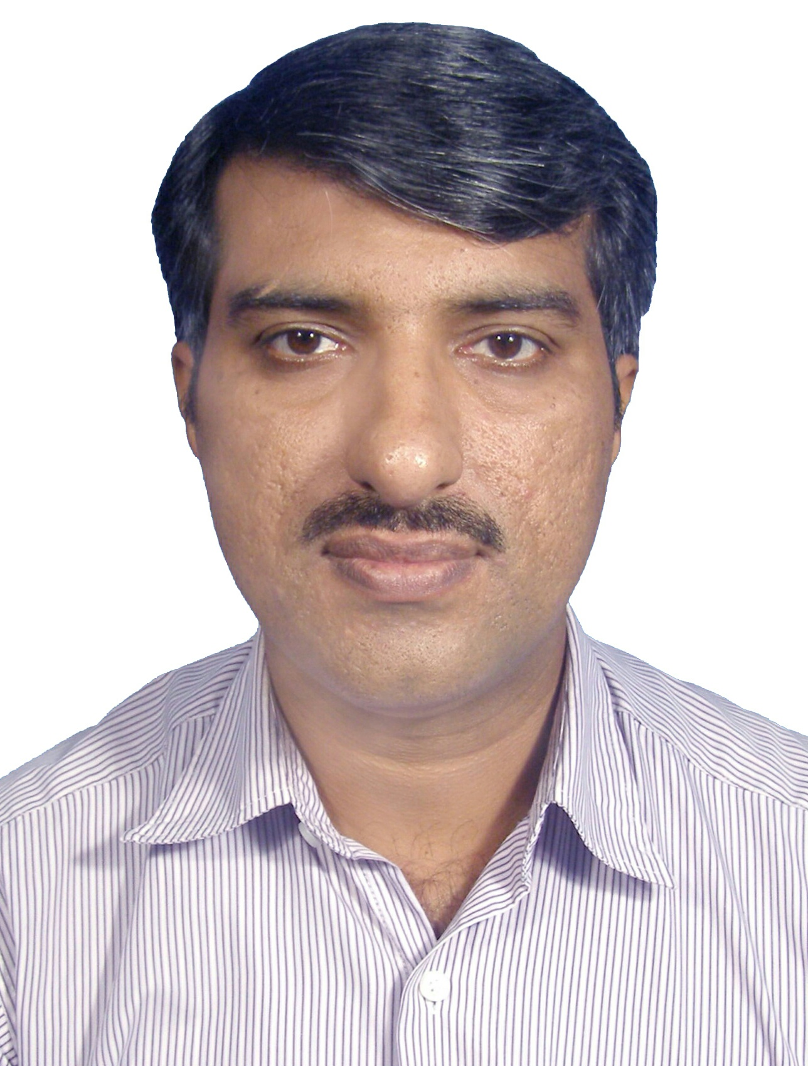

PROFESSIONAL ACADEMICS
- MS Total Quality Management
University of the Punjab (2006-2007)

- Master of Science in Physics(M.Sc)
Government College Lahore (1997 – 1999)

- (OCP) Oracle Certified Professional Internet Application Developer

Oracle Forms Developer Release 6/6i
Oracle Corporation (March 2002)

- Certificate of Achievement in TURBO LINUX: Installation & Configuration
Pakistan Institute of Management, Lahore (April 2002 – June 2002)

ACADEMICS
- Bachelor of Science (B.Sc.)
University of The Punjab, Lahore, Pakistan (1994 – 1996)

- Higher Secondary School (F.Sc.)
Board of Intermediate and Secondary Education, Lahore (1992 – 1994)

- Secondary School Certificate (Matriculation)
Board of Intermediate and Secondary Education, Lahore (1990 – 1992)

FIELD OF SPECIALIZATION
Electronics, Digital Electronics, Metrology/Calibration, Lab Competence Assessment as per ISO-17025:2005 Quality Management, Quality Control and Quality Assurance

METROLOGY & CALIBRATION EXPERIENCE
- Establishing of two Calibration labs at Al Meezan Industrial Metrology Services , Lahore Pakistan and Modern Surveying Calibration and Testing labs. FZE, Erbil Iraql,

As an active member of the team I have been involved in following tasks:

- Setting up of new Calibration Lab at Al Meezan Industrial Metrology Services , Lahore Pakistan and Modern Surveying Calibration and Testing labs, Erbil Iraq
- Procurement of all lab reference standards and their installation (covering metrological parameters of Temperature, Dimension, Pressure, Electrical, Mass & Force, Volume, Time & Frequency, etc).
- Development of Technical & Quality System Procedures & documents in accordance with ISO-17025:2005
- Development of new in-house calibration procedures along with Uncertainty Estimation Procedures and performing their Method Validation.
- Development of MS-Excel Spread Sheets Uncertainty Estimation regarding all the parameters in the scope.

- Practical experience of working in Calibration Lab, APC&I Centre, PCSIR Labs Complex, Lahore with effect from July 14, 2000 to Nov 2013. The said calibration Lab is a secondary level metrology lab working as subsidiary of National Physical Standards Laboratory (NPSL), Islamabad, Pakistan (The NMI of Pakistan). Calibration Lab, APC&I Centre PCSIR Labs Complex, Lahore is one of the three secondary level Metrology Labs working in Pakistan. The other two are in Karachi and Peshawar respectively.

As an active member of the team of Three Metrologists I have been involved in following tasks:

- Setting up of new & up graded Calibration Lab at APC&I Centre, PCSIR Labs Complex, Lahore that can fulfill the role of secondary lab in the province of Punjab.
- Procurement of 126 lab reference standards and their installation (covering metrological parameters of Temperature, Dimension, Pressure, Electrical, Mass & Force, Volume, Time & Frequency, Spectrophotometry).
- Development of Technical & Quality System Procedures & documents in accordance with ISO-17025:1999 and ISO-17025:2005
- Development of 15 new in-house calibration procedures (doc # LLC/APCIC/CP/001 to 015) along with Uncertainty Estimation Procedures and performing their Method Validation.
- Training of 7 Metrologists of the Calibration at APC&I Centre, PCSIR Labs Complex, Lahore, regarding effective use of the lab reference standards, technical & quality system procedures, calibration & uncertainty estimation procedures.
- Development of MS-Excel Spread Sheets Doc # LLC/QMR/FF/058 a, b, c, d, & e to cover Uncertainty Estimation regarding all the parameters in the scope.
- Preparation of Procedure for Intermediate Checks and Stability Studies for the Lab Reference Standards in July 2002 and executing the said procedure since July 2002 to date.
- Prepared the plan & procedure for Interlaboratory Comparison for calibration labs and executed the said Interlaboratory Comparison Program (covering parameters like Electrical, Dimensional, Volumetric, Pressure, Mass, Time interval & Temperature Measurements) with 5 Calibration Labs & National Physical Standards Laboratory in 2003, 2005, 2006, 2008, 2009, 2011 and 2012.
- Arranged & Imparted 7 different trainings to engineers from Industry & Pakistan Navy on calibration of Electrical, Time & Frequency related instruments & Measurement Uncertainty.
- Arranged two seminar / one day workshops on Implementation of ISO-17025:2005 and Metrology on July 8, 2009 and September 6, 2012 respectively.
- Worked as In-charge Electrical, Time & Frequency Measurements Lab & Spectrophotometry/Solution Standards Lab in Calibration at APC&I Centre, PCSIR Labs Complex, Lahore with effect from July 2002 to October 2011. Performed Calibration of instruments like Voltage Reference Standards, Multimeters, Clamp Meters, Voltmeters, Ampere Meters, Capacitance Meters, Inductance Meters, Power Meters, Energy Meters, Multifunction Electrical Calibrators, Power Calibrators, Multifunction Process Calibrators, Resistance Standards, Resistance Boxes, Meggers/Insulation Testers, Earth Testers, Milli Ohmmeters, RPM Meters, Stroboscopes, Frequency Counters, Frequency Generators, db Power Meters, Timers & Stopwatches etc.
- Worked as Associate Metrologist in Temperature Measurement Lab, Pressure & Hyrdostatic Measurement Lab and Volumetric Measurement Lab in Calibration at APC&I Centre, PCSIR Labs Complex, Lahore with effect from July 2002 to October 2011.
- Worked as Associate Metrologist in Dimensional Measurement Lab and Mass & Force Measurement Lab in Calibration at APC&I Centre, PCSIR Labs Complex, Lahore with effect from July 2000 to April 2008.
- Worked as Associate Metrologist in Electrical, Time & Frequency Measurements Lab & Spectrophotometry/Solution Standards Lab in Calibration at APC&I Centre, PCSIR Labs Complex, Lahore with effect from July 2000 to June 2002.
- Calibration of Laboratory & Industrial Process Control Equipment for various clients from industry, public & private labs, hydropower projects, and other research organizations within Pakistan with effect from July 2000 to date (In calibration laboratory and Onsite).

ISO/IEC 17025:2005 TECHNICAL ASSESSMENT EXPERIENCE
Official Technical Assessor for:
- Pakistan National Accreditation Council (PNAC)
- Emirates National Accreditation Services (ENAS)

Technical Assessments as per ISO/IEC 17025:2005 performed:

Sr # | Accreditation Body | Laboratory Assessed | Month & Year
 | GAC | Betalink Instrumentation and Calibraiton, Abu Dhabi | July 2015
 | PNAC | Dimensional Metrology Lab, POF, Wah, Pakistan | July 2013
 | PNAC | Calibration Lab, Miraj Rebuild Factory, Kamra, Pakistan | July 2013
 | PNAC | Precision Measurement Electrical Lab, 509, Gujranwala, Pakistan | June 2013
 | ENAS | EMIS, Intertek, Abu Dhabi, UAE | April 2013
 | ENAS | Metromac, Calibration & Automation Services, Abu Dhabi UAE | April 2013
 | ENAS | QCAL, Qatar Calibration & Instrumenation Services, Qatar | April 2013
 | PNAC | Calibration Lab, Avionics Production Factory, Kamra, Pakistan | January 2013
 | ENAS | Calibration Lab, Rohde & Schwarz, Abu Dhabi, UAE | December 2012
 | PNAC | National Physical Standards Lab, Islamabad, Pakistan | November 2012
 | PNAC | Calibration Lab, Attock Refinery, Rawalpindi, Pakistan | November 2012
 | ENAS | EMIS, Intertek, Abu Dhabi, UAE | May 2012
 | PNAC | Direct Line Calibration Laboratory, Lahore, Pakistan | April 2012
 | ENAS | Calibration Lab, Rohde & Schwarz, Abu Dhabi, UAE | February 2012
 | PNAC | Calibration Lab, Avionics Production Factory, Kamra, Pakistan | January 2012
 | PNAC | Calibration Lab, Miraj Rebuild Factory, Kamra, Pakistan | January 2012
 | PNAC | Calibration Lab, Attock Refinery, Rawalpindi, Pakistan | December 2011
 | PNAC | Precision Measurement Electrical Lab, 509, Gujranwala, Pakistan | December 2011
 | PNAC | National Physical Standards Lab, Islamabad, Pakistan | October 2011
 | PNAC | Dimensional Metrology Lab, POF, Wah, Pakistan | July 2011
 | PNAC | Precision Measurement Electrical Lab, 107, Karachi, Pakistan | May 2011
 | ENAS | Calibration Lab, Rohde & Schwarz, Abu Dhabi, UAE | February 2011
 | PNAC | Calibration Lab, Miraj Rebuild Factory, Kamra, Pakistan | February 2011

JOB EXPERIENCE

I JOB TITLE : Visiting Lecturer
ORGANIZATION : Al- Mumtaz Computer College, Shalimar Link Road, Mughalpura Lahore.
DURATION : June1997 to July 2000
RESPONSIBILITIES :

- To deliver Lectures on the subjects like Digital Electronics, Physics, Introduction to Computer Sciences, Microsoft Office 97, 2000, Oracle SQL/PLSQL, Oracle Developer 2000 and C++.
- To prepare, conduct and check papers.
- To conduct Practical classes of Physics for ICS / F.Sc.
- To conduct Practical classes of Digital Logic and Computer Design for BCS.

II JOB TITLE : Visiting Faculty Member
ORGANIZATION : NICON College of Computer Sciences, Model Town Extension Lahore.
DURATION : April 2003 to September 2003
RESPONSIBILITIES :

- To deliver Lectures on the subjects like Electronics and Digital Logic & Computer Design for BCS and MCS Classes
- To prepare, conduct and check papers.

III JOB TITLE : Scientific Officer
ORGANIZATION : Applied Physics Computers and Instrumentation Centre,
Pakistan Council of Scientific And Industrial Research Laboratories Complex,
Lahore.
DURATION : July 2000 to August 2006
RESPONSIBILITIES : In-charge Electrical Time and Frequency Standards Lab / AQM

JOB TITLE : Senior Scientific Officer / Technical Manager Calibration Lab.
ORGANIZATION : Applied Physics Computers and Instrumentation Centre,
Pakistan Council of Scientific And Industrial Research Laboratories Complex,
Lahore.
DURATION : August 2006 to November 2013
RESPONSIBILITIES : Technical Manager Calibration Lab.
In-charge Electrical Time and Frequency Standards Lab / TMR

- Preparation of Quality Manual, Quality System Procedures, Work Instructions and Forms & Records for the implementation of ISO 9001:2000 and ISO 17025:2005.
- To prepare documentation like Standard Procedures for Calibration, Calibration Certificates and Correspondence regarding Repair & Maintenance Activities.
- Development of QC/QA procedures, including Procedure for Operator Competence, Procedure for Method Validation and Implementation of Statistical Tools & Techniques for effective implementation of Lab. QMS.
- To conduct Internal Audits regarding ISO-17025 and ISO-9001 as per internal audit plan.
- To calibrate and standardize the Industrial and Laboratory Instruments.
- To deliver lectures on In-house Calibration of Industrial and Laboratory Instruments.
- To design and develop Electronic Control Circuits for various Laboratory Instruments.
- Repair and maintenance of Scientific/Analytical Laboratory Instruments.
- To deliver lectures regarding operation and maintenance of various Sophisticated Scientific Instruments.

JOB TITLE : Head / Officer In-Charge.
ORGANIZATION : Centre for Development of Laboratory Equipment,
Pakistan Council of Scientific And Industrial Research Laboratories Complex,
Lahore.
DURATION : September 2010 to Nov 2013
RESPONSIBILITIES : Over All Management of the Centre
Technical Manager Calibration Lab.
In-charge Electrical Time and Frequency Standards Lab / TMR

- Overall Management of day to day affairs of the centre.
- To supervise the development of new laboratory equipment being developed at the centre.
- To supervise the R&D projects being carried out at the centre.
- Planning, reporting and managing the jobs, tasks, assignments being referred to the centre.
- Managing the employees (technical and non-technical) of the centre.

IV. JOB TITLE : Technical Manager / Incharge Electrical, Time and Frequency Lab
ORGANIZATION : Modern Surviyer Calibration Lab FZE, DAFZA Dubai and Erbil Iraq.

DURATION : Nov 2013 to Sep 2016
RESPONSIBILITIES : Technical Manager Calibration Lab.

In-charge Electrical Time and Frequency Standards Lab
- Preparation of Quality Manual, Quality System Procedures, Work Instructions and Forms & Records for the implementation of ISO 17025:2005.
- Achieving accreditation status for Modern Surveying calibration and testing labs in Dec 2015 for 22 metrological parameters.
- To prepare documentation like Standard Procedures for Calibration, Calibration Certificates and Correspondence regarding Repair & Maintenance Activities.
- Development of QC/QA procedures, including Procedure for Operator Competence, Procedure for Method Validation and Implementation of Statistical Tools & Techniques for effective implementation of Lab. QMS.
- Procurement of Lab Ref. Calibration Standards and their installation.

V. JOB TITLE : General Manager,
ORGANIZATION : Al Meezan Industrial Metrology Services, Lahore Pakistan.

DURATION : Sep 2016 to Date
RESPONSIBILITIES : General Manager.

- Overall management of day to day operations
- Preparation of Quality Manual, Quality System Procedures, Work Instructions and Forms & Records for the implementation of ISO 17025:2005.
- To prepare documentation like Standard Procedures for Calibration, Calibration Certificates and Correspondence regarding Repair & Maintenance Activities.
- Development of QC/QA procedures, including Procedure for Operator Competence, Procedure for Method Validation and Implementation of Statistical Tools & Techniques for effective implementation of Lab. QMS.
- Procurement of Lab Ref. Calibration Standards and their installation.

PROJECTS

- Setting up of New Calibration Lab At Al Meezan Industrial Metrology Services, Lahore, Pakistan
Worked as a business partner and General manager to setup and establish a new calibration lab at Lahore, Pakistan.

- Setting up of New Calibration Lab At Modern Surviyer Calibration FZE, Erbil Iraq
Worked as a member of a team of two Sr. Metrologists to Set up of new Calibration Lab at Erbil, Iraq.

- Setting up of New & Up graded Calibration Lab At APC & ICentre PCSIR Labs Complex Lahore
Worked as a member of a team of three Sr. Metrologists to Set up of new & up graded Calibration Lab at APC&I Centre, PCSIR Labs Complex, Lahore that can fulfill the role of secondary lab in the province of Punjab.

- Implementation of ISO 9001:2000
Worked as Assistant Quality Manger during 2002-2003 for the development of Quality System documentation regarding Implementation of ISO 9001:2000 at APC & I Centre.

- Implementation of ISO 17025:2005
Worked as Assistant Quality Manger during 2003-2005 for the development of Quality System Manual Quality System Procedures, Work Instructions, Forms & Records, Control Charts and Related Analysis regarding Implementation of ISO 17025:2005 at APC & I Centre.

- Dry Block Thermocouple Digital Calibrator
Designed and developed a Digital Calibrator for calibration of Thermocouples and temperature sensors.

- Automatic Temperature Controlled Heating System for Injection Moulding Machine
Designed and developed Automatic Temperature Controlled heating system for Injection moulding Machine for M/s Model Sports, Sialkot.

- Calibration System for Clamp-meters
Designed and developed Calibration System for Clamp-meters with calibration range up to 300 A.

- Calibration System for Meggers
Designed and developed Calibration System for Meggers with calibration range up to 2200 MΩ

- Calibrator for 4 pin Earth Testers
Designed and developed Calibrator for 4 pin Earth Testers based on IEEE-80

COMPUTER SKILLS
A good hands on experience of hardware trouble shooting, software and hardware installation.
Have a good administration experience of Win 2003 and win 2007 Network.

- Tools
Oracle Project Builder, Oracle Developer 2000, JBUILDER
- Databases and RDBMS
Oracle SQL/ PL SQL, MS SQL Server, My SQL, MS Access and Oracle 9i
- Graphic Designing and Animation
MS paint, Corel Draw, Adobe Photoshop
- Computer Simulation & Scientific Software
Minitab 14, Harvard Graphics, Circuit Maker 5.0 and Electronic Workbench
- Operating Systems
DOS, Windows 3.11, Windows 95, Windows 98/Me, Windows NT/2000, Windows XP, Windows Vista & 7, Mandriva Linux 2010, Turbo Linux 7.0, Linux Red Hat 9.0
- Office Software
MS-Office 2003 to 2010 (a good hands on experience in efficient use of MS-Word, MS-Excel Sheets, MS-Power Point, MS-Project)

LINGUISTIC SKILLS
- Proficient in written and spoken English. (7.5 overall Band in IELTS).
- 70 hours Certificate of basic Japanese language.
- National Language: Urdu
- First Language: Punjabi

DISTINCTIONS

Stood 2nd in the paper reading contest (1999) held under the auspices of Jones Physics Society Government College Lahore.

Stood 3rd in the Essay writing contest (1999) held under the auspices of Jones Physics Society

Government College Lahore.

Received honorarium for completing a project on repair and maintenance of Scientific Instruments in various Scientific Organization in the province of Punjab.

TRAININGS
- Course Title : ISO-17025 Assessor Training Course
Institute : Pakistan National Accreditation Council (PNAC), Islamabad & APLAC.

- Course Title : Training on Quality Tools and Techniques for Quality Inspectors
Institute : Pakistan Institute of Quality Control, Lahore.

- Course Title : Trainers Training
Organization : Small & Medium Enterprise Development Authority, Defense Lahore.

- Course Title : Operational Amplifier
Institute : Staff training Institute, Gulberg, Lahore.

- Course Title : Work Shop on Computer Interfacing
Institute : The University of Punjab

- Course Title : Heat Treatment and Metal Finishing Technologies for Improving Metal Properties
Institute : AIRI and Chubu International Centre, Nagoya, Aichi. JICA- Japan.

- Course Title : Microprocessor
Institute : Staff training Institute, Gulberg, Lahore.

- Course Title : Work Shop on port to LINUX from Windows
Institute : OpenTech institute of Computer Training, Gulberg Lahore.

- Course Title : Operation & Administration Level Training of Windows 2003 Server and
ISA Server 2000
Institute : Premier Systems Pvt. Ltd, Lahore.

PERSONAL DETAILS
- NATIONAL IDENTITY CARD # : 35202-3478576-3
- RELIGION : Islam
- NATIONALITY : Pakistani
- Marital Status : Married

